**WEEK – 6 Assignments**

**React**

**Mandatory hands-on :-**

**1. ReactJS-HOL :**

**Objective :**

In this hands-on lab, you will learn how to:

· Set up a react environment

· Use create-react-app

**Created react app:**

**Code :**

[**App.js**](http://app.js) **:**

| **function App() {  return (  <h1  style={{  textAlign: "center",  marginTop: "40px",  fontFamily: "Arial, sans-serif",  }}  >  Welcome to the first session of React  </h1>  ); }  export default App;** |
| --- |

**OUTPUT :**

**npm start :**

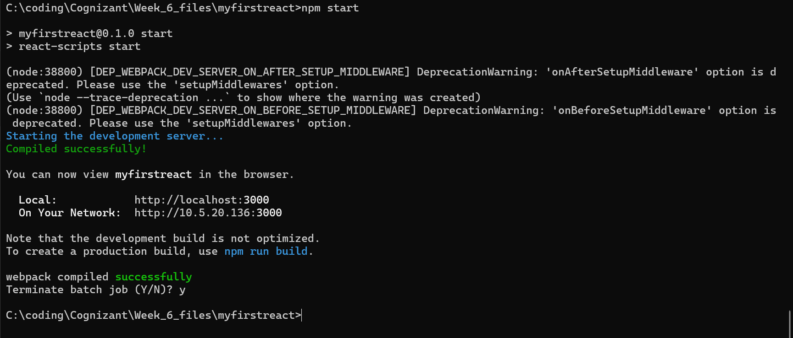

**Localhost:3000 :**

